**Objective question 2**

Answer (c). When the individual exits the trampoline board, it is just conservative (its weight) that works on it. The athlete-earth device therefore retains its overall mechanical energy throughout its flight: Kf + Uf = Ki + Ui. Also, when the full height is exceeded, her speed is zero or Kf = 0. This gives the maximum height as Uf = Ki or mgymax = 1⁄2 mvi2

ymax =v2i

2g=(8.5 m/s)2

2(9.80 m/s2) = 3.7 m.

**Problem 7**

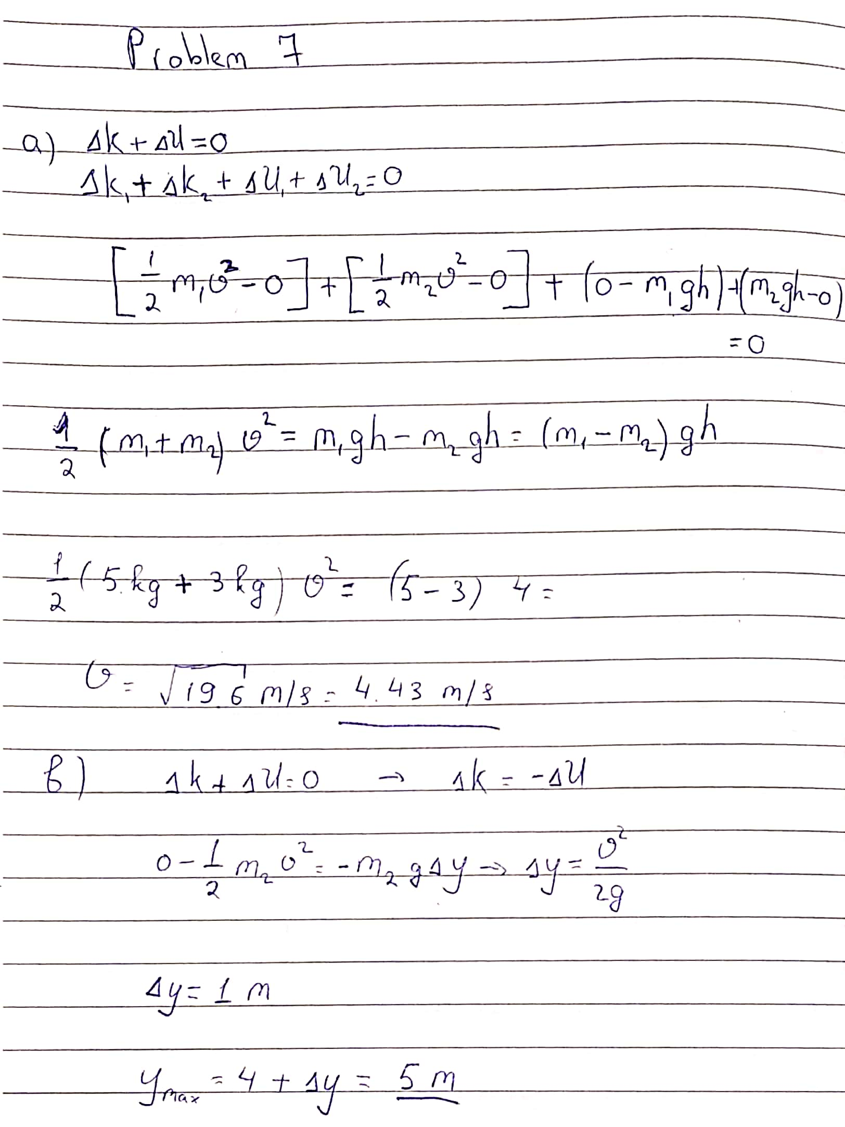

Thank you

Student ID : 201923250

Name : Kobilov Ilkhomjon